**NAME:** - ANSHUL SAINI  
**MAIL:** - [sainianshul7565@gmail.com](mailto:sainianshul7565@gmail.com)

**User ID**: - 34732

**Date: -** 12/08/2025

**Batch: -** DWS_B5_25VID2550

**Topic Assignment: -**

**PowerShell App Deploy Toolkit**

* Execute-MSI - Installation and Uninstallation
* Execute-Process
* Execute-MSP
* Install-MS Updates
* Copy/Delete/Move File and Folders

**PowerShell App Deploy Toolkit**

* **Execute-MSI - Installation and Uninstallation: -**

This command is used to install or uninstall MSI-based applications. For example, you can run Execute-MSI -Action Install -Path "app.msi" to install, or change the action to Uninstall to remove it. This makes MSI deployments very straightforward.

**Practice Activity: -**

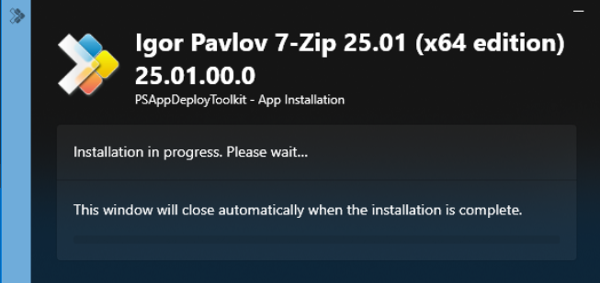

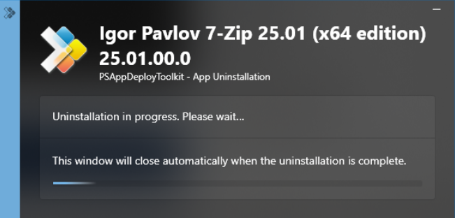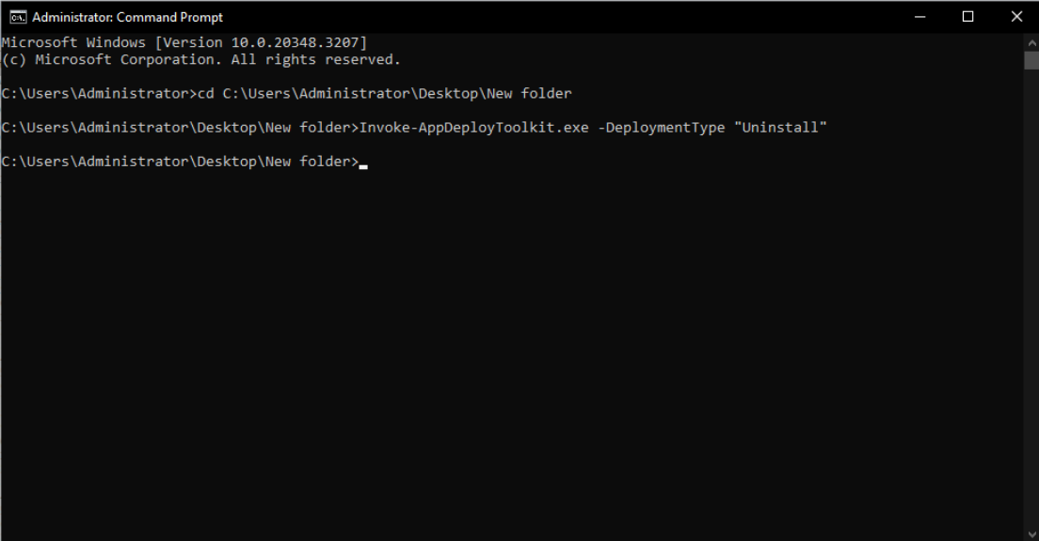

* **Execute-Process: -**

The Execute-Process function runs EXE files or any program from within the script. This is useful for installing software that doesn’t come as an MSI, or for running helper tools during deployment.

Execute-Process -Path '7z2501-x64.exe' -Parameters '/S' -WindowStyle 'Hidden'

**Practice Activity: -**

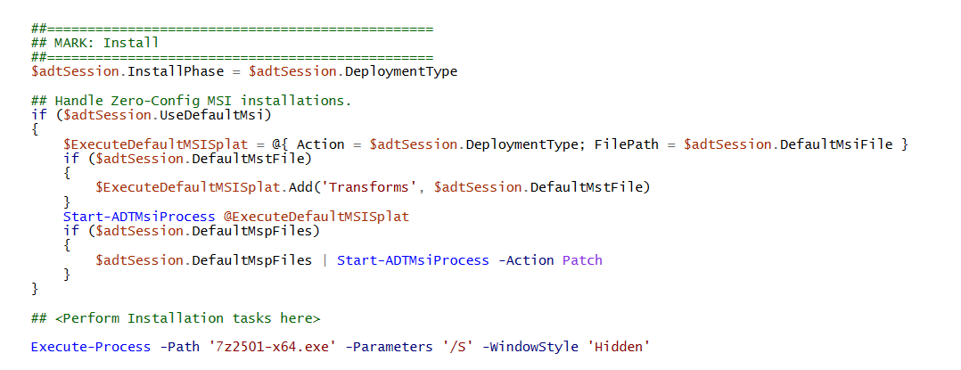

* **Execute-MSP: -**

The **Execute-MSP** command in the PowerShell App Deployment Toolkit (PSADT) is used to apply Microsoft Installer Patch files (.msp) to an existing MSI-based application. MSP files are commonly used for hotfixes, security updates, or minor upgrades without reinstalling the whole application. This function allows you to automate patch installation silently while logging the process. It supports additional parameters like transforms and properties, ensuring the patch is applied consistently across multiple systems without requiring manual user intervention.

**Practice Activity: -**

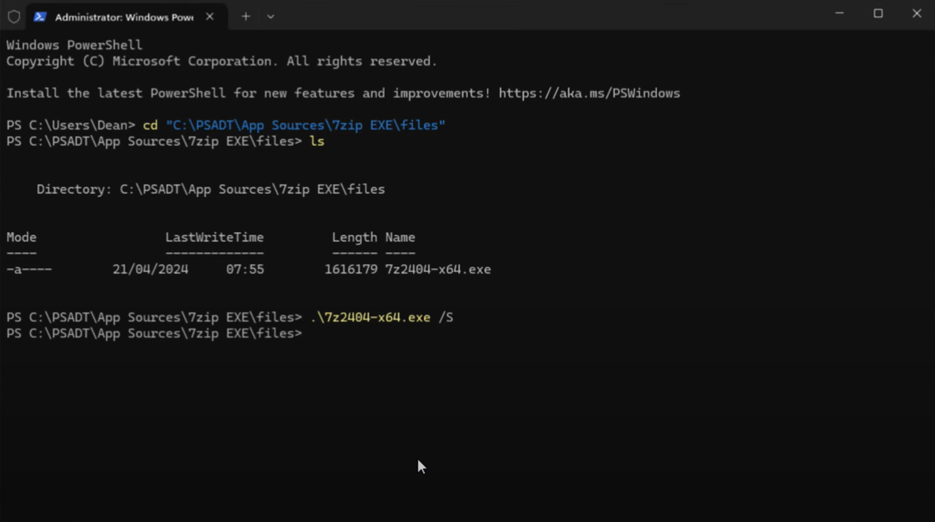

* **Install-MS Updates: -**

The Install-MSUpdates function in PSADT is designed to install Microsoft Update Standalone Installer (.msu) files. These updates could include security patches, Windows feature updates, or hotfixes that are not distributed via Windows Update. The function executes the update silently, optionally suppresses reboot prompts, and logs the entire process. Using this feature ensures that updates are deployed in a controlled manner during software installation or maintenance, which is especially useful in enterprise environments for maintaining security and compliance.

SYNTAX

Test-MSUpdates [-KBNumber] <String> [[-ContinueOnError] <Boolean>] [<CommonParameters>]

**Practice Activity: -**

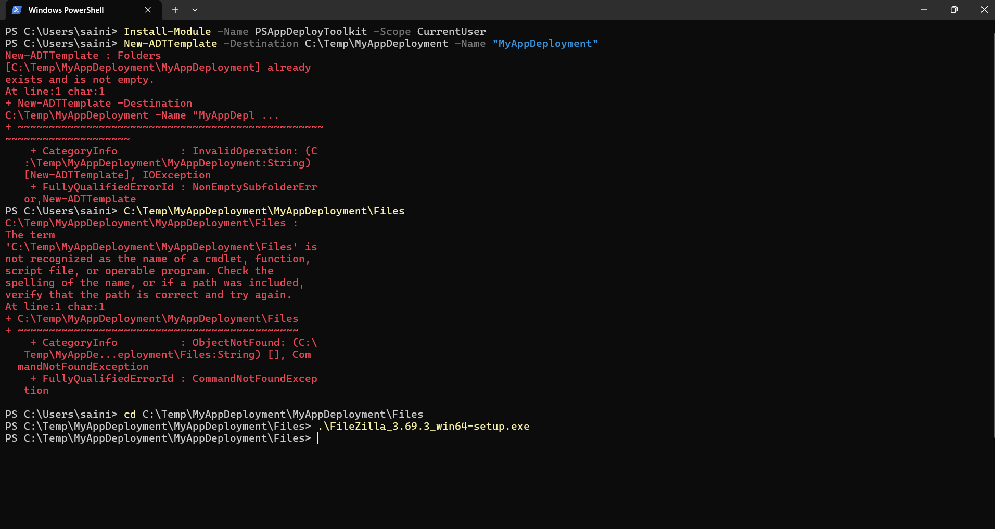

* **Copy/Delete/Move File and Folders: -**

In PSADT, file and folder operations such as copy, delete, or move are handled using built-in functions or standard PowerShell commands integrated within the toolkit scripts. This capability is often used during deployments to copy configuration files, remove outdated files, or relocate data to appropriate directories. The process can be executed silently with error handling and logging, ensuring that required files are in place and unnecessary or old files are cleaned up, maintaining the integrity and efficiency of the deployed application.

SYNTAX

Copy-File [-Path] <String[]> [-Destination] <String> [-Recurse] [-Flatten] [-ContinueOnError <Boolean>]

[-ContinueFileCopyOnError <Boolean>] [-UseRobocopy <Boolean>] [-RobocopyParams <String>]

[-RobocopyAdditionalParams <String>] [<CommonParameters>]

Remove-Folder [-Path] <String> [-DisableRecursion] [[-ContinueOnError] <Boolean>] [<CommonParameters>]

**Practice Activity: -**

